**Course Outline**

requirement : Coppeliasim version >=4.2, with ROS installed

***Overview***

1. Intro
   1. CoppeliaSim main features
   2. Physics engines
   3. Entities
   4. Control modules (Features)
2. User interface
   1. Tools bars (move, rotate)
   2. Model browser
   3. Scene hierarchy
3. Import Model
   1. Tutorial→Building a clean model tutorial
   2. Functionallity→Import/Export
   3. import create model
   4. Task: try to create shape from diff approaches, vortex, edge, triangular
4. Object Properties
   1. Entities → Scene objects → object properties
   2. common
   3. body dynamic, respondable, dynamic
   4. add simple joint and control it (show example motorcontrollerExamples)
   5. Q?: How to avoid collision of two object connected with joint
5. Coding Basic
   1. Writing code in and around CoppeliaSim
   2. type of control (Embedded, Remote)
   3. type of script (main, child, custom)
   4. running order (init, loop, end)
   5. Define object Handle (Writing code in and around CoppeliaSim → CoppeliaSim API framework → Regular API reference)
      1. sim.getObjectHandle()
6. Sensor & Actuators
   1. plot graph (Entities → Scene Object → Graph)
   2. read joint data
      1. position, sim.getJointPosition
      2. velocity, sim.getJointVelocity
      3. torque, simGetJointForce
   3. Control joint
      1. Task: position, sim.setJointPosition, sim.setJointTargetPosition
      2. Task: velocity, sim.setJointTargetVelocity
   4. proximity sensor
      1. Example → Proximity sensor Demo
      2. read data
      3. modifies properties
   5. Vision
      1. add Floating view (right click on mouse → floating view)
   6. IMU
      1. Show example
      2. euler angle , alpha beta gamma
      3. yaw pitch roll (sim.getObjectOrientation, sim.alphaBetaGammaToYawPitchRoll)
      4. Accelrerometer
      5. Communicate between 2 script, global parameter, signal
7. Break
8. connect Vrep with ROS
   1. install plugin
   2. load plugin
   3. ROS interface helper
   4. Debugging Topics, node
9. Create Extreme Terrain
   1. complex terrain model
   2. import height field
10. Additional regular API
    1. How to start , Stop Simulation with script
       1. sim.startSimulation ()
       2. sim.pauseSimulation ()
       3. sim.stopSimulation()
    2. setObjectPosition, with script
       1. sim.setObjectPosition()
    3. getvideo in simulation with C++ or Lua script ?
    4. Render V-REP (CoppeliaSim) simulations in **Blender**
       1. https://www.youtube.com/watch?v=aevqp5xcfTQ

**Lesson**

**Joe**

* How to import STL file to V-rep and layout part
* Object Properties

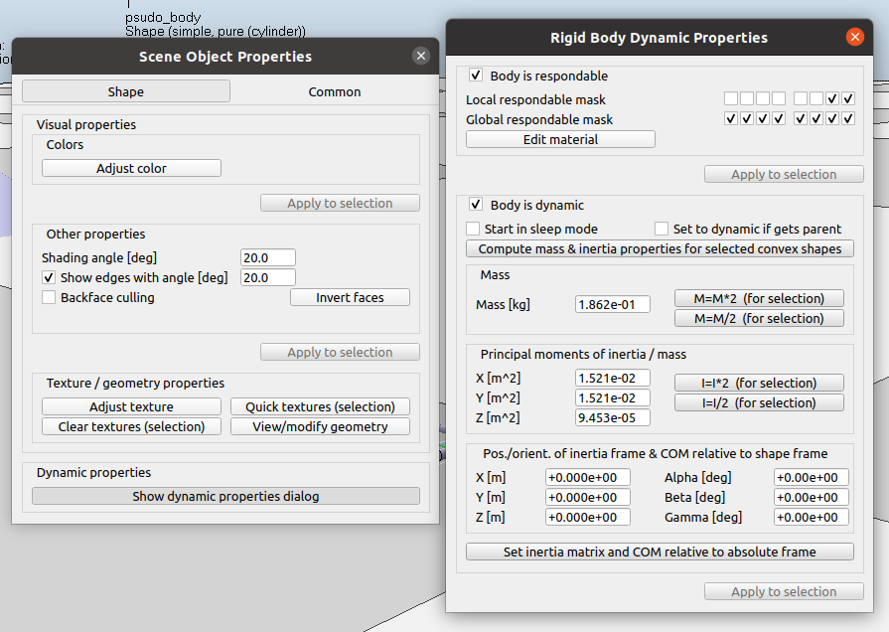

* syntax of lua file → structure of lua file
  + init function
  + sensor function
  + etc
  + How to start , Stop Simulation with script
  + setObjectPosition, with script
* How to add joint to the robot
  + Get motor value
    - torque
    - position
    - velocity
* How to add sensor and get the value
  + force
  + IMU
  + distance
  + lidar
  + etc
* How to plot graph on sim screen
* How to connect with ROS and make a lua file
  + How to start , Stop Simulation with script
* How to Change environment and create extreme terrain

Won :

* How to start , Stop Simulation with script
* setObjectPosition, with script
* getvideo in simulation with C++ or Lua script ?
* Render V-REP (CoppeliaSim) simulations in Blender
  + https://www.youtube.com/watch?v=aevqp5xcfTQ

**______________________________**